Searching Functionality Demo:-
- For Quick Search:-
If you entered keyword of product name, then all related product will be shown according to keyword.
For example: - According to keyword ‘a’

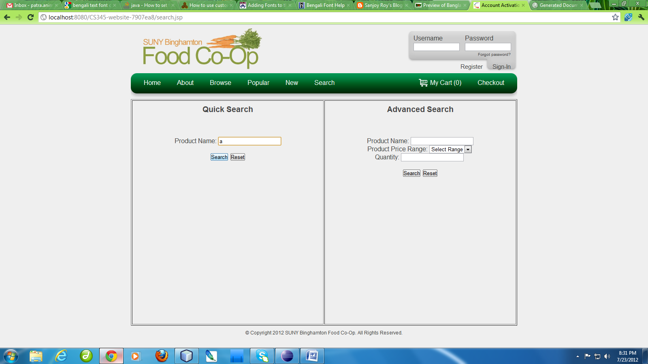

Product shown which have keyword ‘a’
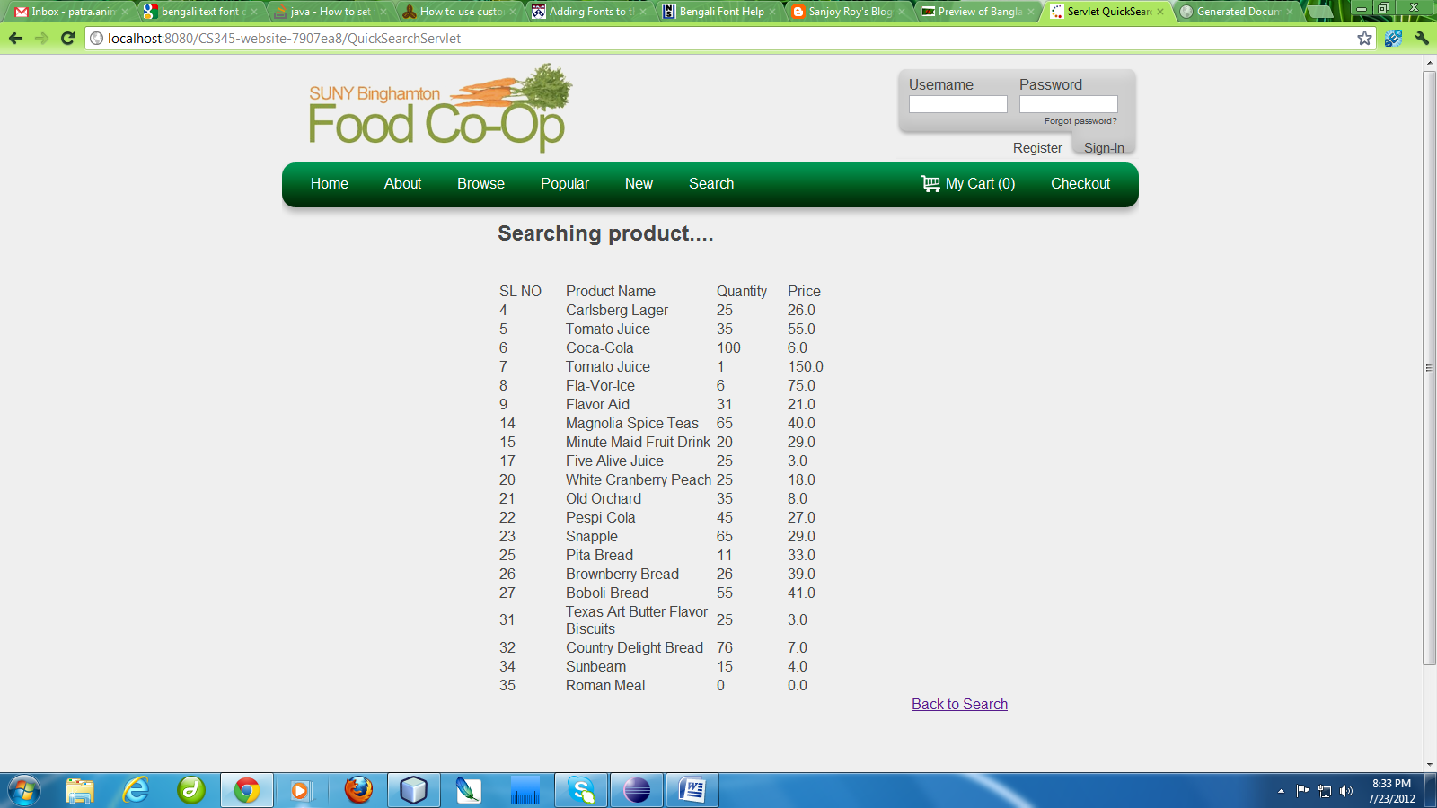

Similarly when we enter keyword ‘Bread’

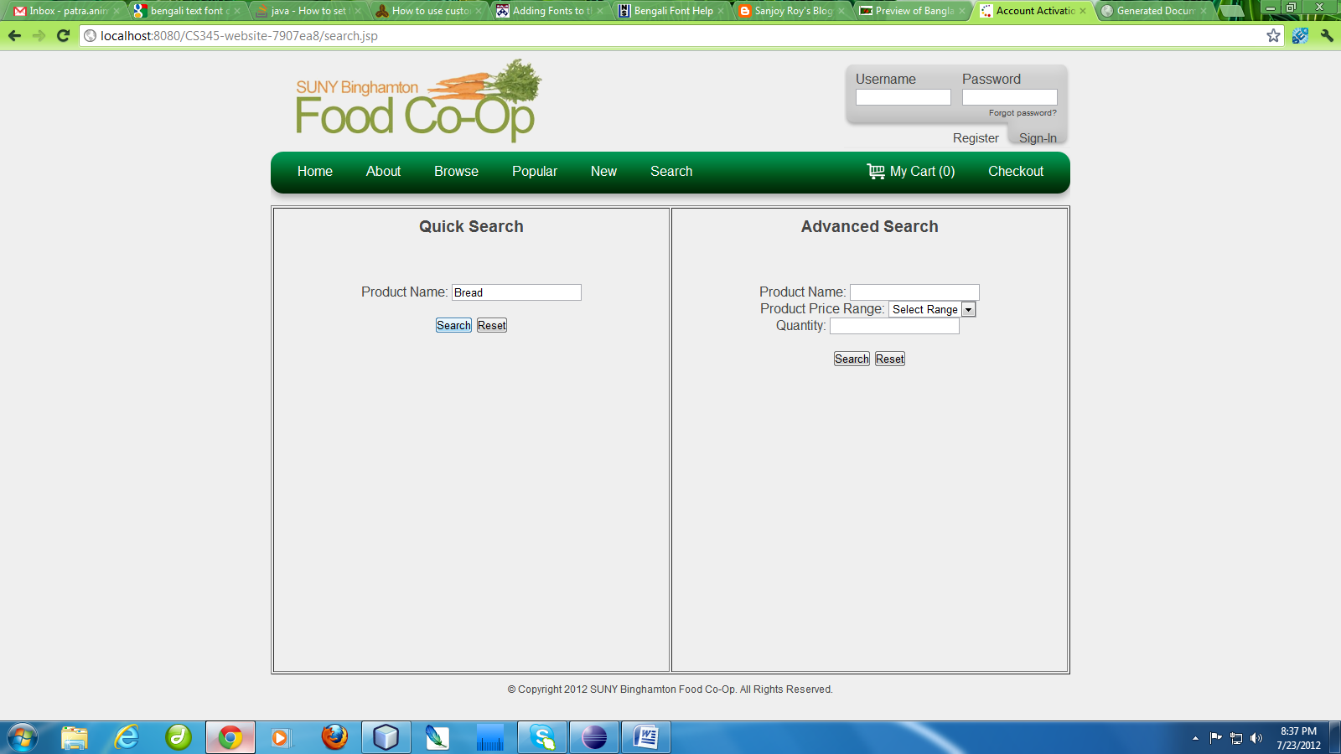

Output will be

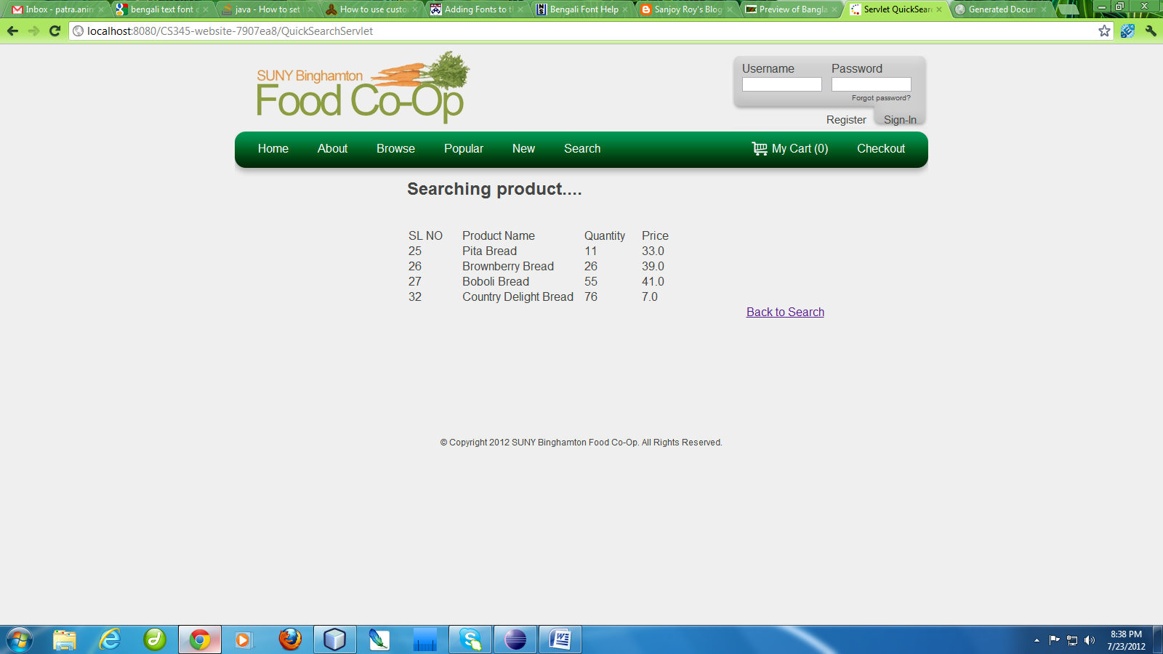

- For Advanced Search:-
Product will search according to parameter like product price, quantity of product in database.
If you entered only keyword of product name, then searching will be similar to quick search.

Example1:- When we enter keyword ‘Bread’ with parameter like price less than 10$ and quantity 5. Then we get product which have name Bread and price less than 10$ and quantity in stock greater than 5 will be shown
